

- Our members and friends who are living in a nursing home, assisted living, or are partially or fully "home-bound”
- Janet Parrish-health concerns
- Joyce Miles as she undergoes cancer treatments
- Pia Ison as she undergoes chemotherapy treatments
- Eldon Steinfort as he recovers from a fall.
- Those who sustained storm damage.

We encourage you to pray for these friends – send them a note, call, or visit them. Addresses and phone numbers can be obtained from the church office. Send your prayer requests, concerns, and updates to office@fpcjc.com

Notice of Filming: Worship services are filmed and recorded to be included on our Church website, Facebook, YouTube, etc. While most footage will feature worship leaders, video of the congregation may also appear. Children may be seen during children’s sermons. If you have concerns, please get in touch with the church office.

FIRST PRESBYTERIAN CHURCH
We strive to be a loving family of faith, nurturing the spiritual growth of one another as we serve, worship, and reach out in celebration of Christ's Love.

June 14, 2026

Prelude Love Divine, All Love Excelling . . . Peter Benjamin
Gather In God’s Name

Welcome and Announcements

Musical Introit

Call to Worship

Leader: Our help is in the name of the Lord, who made heaven and earth.
People: O come, let us worship and bow down; let us kneel before the Lord our Maker.
Leader: For He is our God; and we are the people of His pasture, and the sheep of his hand.
People: If thou shalt seek the Lord they God, thou shalt find Him, if thou seek Him with all they heart, and with all they soul.
Leader: God is a spirit; and they that worship Him must worship Him in spirit and in Truth.
ALL: The Lord’s name be praised.

*Hymn of Praise #39 How Great Thou Art

*The Peace
(Please greet one another and exchange signs of peace and reconciliation

Invitation To, and Prayer of Confession
Leader: The Lord is gracious and full of compassion; slow
to anger, and of great mercy.
People: The Lord is good to all; and His tender mercies
are over all His works.
Leader: The Lord is nigh unto all that call upon Him, to all that
call upon Him in Truth.
People: He will fulfill the desire of them that fear Him;
He also will hear their cry, and will save them. Amen

Assurance of Pardon
Leader: Dear Heavenly Father, we lower our heads before you
and we confess that we have too often forgotten that
we are yours. Sometimes we carry on our lives as if there was no God and we fall short of being a credible witness to You.
People: For these things we ask your forgiveness and
we also ask for your strength. Hold us near You and build our relationship with You and with those You have given us on earth.

In the grace and love of God, we are forgiven. Thanks be to God!

*Response to Forgiveness Gloria Patri Hymn #581
Glory be to the Father, and to the Son, and to the Holy Ghost; as it was in the beginning, is now, and ever shall be, world without end. Amen. Amen.

Proclaim God’s Word
Prayer

First Lesson Romans 5:6-15 Leader: The word of the Lord
People: Thanks be to God.

Special Music Melody in F by A. Rubinstein
Piano Duet, Sally Jardine & Shelia Markley

Children’s Moment

Second Lesson: Matthew 9:35-38; 10:7-20

Sermon: “EVEN IF”

Respond To God’s Word
Prayer Requests, Joys, and Concerns

Prayers of the People

Invitation to Offering

Offertory Teach Us, O Lord . . . David Paxton

*Doxology and Prayer (Offertory Response, Hymn #606)

Prayer (Unison)
O God, who needs not to be enriched with any gifts that we may bring, yet who loves the cheerful giver. Receive these our offerings which we present before you, and with them ourselves, our souls, and our bodies, a living sacrifice, holy and acceptable to you; through Jesus Christ our Lord. Amen

Invitation to the Table

Great Prayer of Thanksgiving and the Lord’s Prayer
Leader: The Lord be with you.
People: And also with you.
Leader: Lift up your hearts.
People: We lift them to the Lord.
Leader: Let us give thanks to the Lord our God.
People: It is right to give our thanks and praise.
Leader: Blessed are you, O lord our God…
Through the Lord Jesus Christ, in the unity of the Spirit,
We bless you, God of glory, now and forever. Amen

The Communion of the People

Prayer after Receiving (Unison)
Holy Spirit, you have filled us with your life.
Christ our Savior, you have embraced us in your love.
Lord God like a Mother you have fed us with your grace.
Now send us out into your beloved world
To share your life, your love, your grace with all.
Blessing and honor and glory to you,
Holy, Holy, Holy Lord. Amen

Go In God’s Name

*Hymn of Commitment #300
They’ll Know We are Christians by Our Love

*Benediction Response #542
God Be with You till We Meet Again (vs 1)

Postlude Boundless Grace . . . David Paxton
*Please rise in body or in spirit.
No Coffee Fellowship during summer months; however, please stay tuned for special Fellowships coming your way in June & July.

Pastor: Nathanael Hood
Christian Youth Coordinator: Dawn Avery
First Presbyterian Church
113 W. 5th Street, Junction City, KS 66441
Website: https/www.fpcjc.com
Office Phone: 785-238-1191
Office Hours: 9 a.m. – 12:00 noon & 12:30 p.m. – 2:30 p.m.

CALENDAR FOR THE WEEK

Day/Date | Time | Event
June 6-22 |  | Pastor Nate’s Vacation
Thursday, June 24 | 11:00 a.m. | Staff meeting
Sunday, June 21 | 10:45 a.m. | Worship

Church Services Online:
Stream our church services at: https://www.fpcjc.com
Links to our Facebook and YouTube pages are available on the site. The worship bulletin can also be found there.

Thank you to all who assisted in this morning’s worship service:

Guest Preacher: Kathleen Marsicek
Worship Leader: Rev. Robert Frasier
Chancel Choir Director: Joe Markley
Music Coordinator & Handbell Director: Sheila Markley
Organist/Pianist: Rhoda Frasier
Video Preparer/Operator/Sound: Colleen Smith
Key Deacon for June: Chrystal Artigue (785-561-0473)
Elder for the month of June: Margaret Kilpatrick (785-762-2780)
Head Usher for June: Margaret Kilpatrick

Children Are Welcome in Worship. We joyfully welcome all children and youth to stay and participate in the worship service as we experience God together. Please note there will be no childcare offered in the Nursery June through August.


The flowers in the sanctuary this morning are provided by Arthur and Andrea Cassity and Erin Cassityhales, to the Glory of God and in memory of their grandparents A. D. & Maude Jellison.


Our special music today has been provided by
Sally Jardine & Shelia Markley. Thank you for sharing your gift of music.

Free Junction City Community Band concerts are every Sunday in June. Concerts begin at 3:00 in the C. L. Hoover Opera House located at 135 W 7th Street, Junction City, KS.
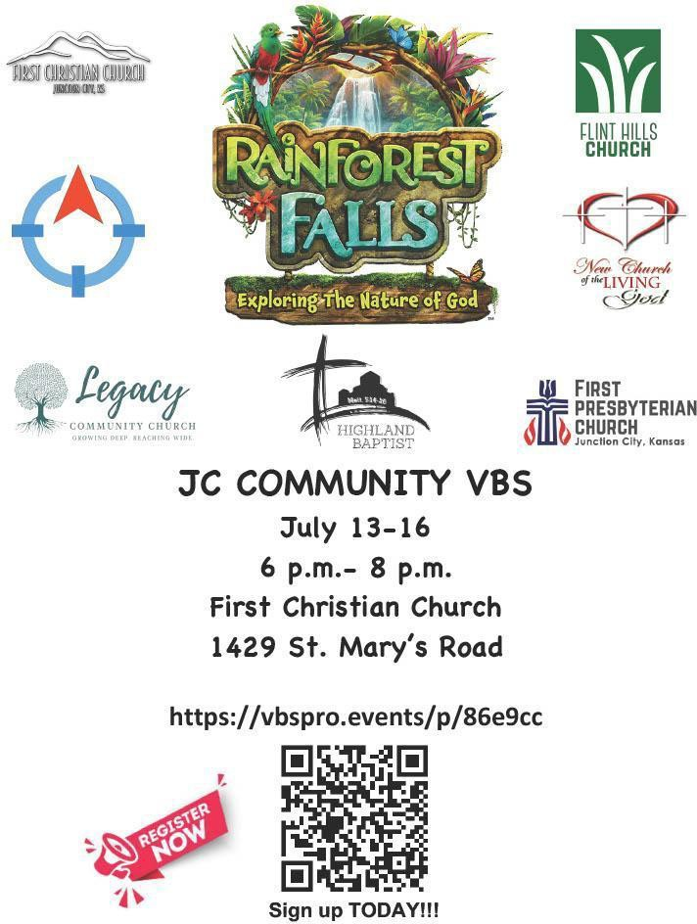
Register Now for JC COMMUNITY VBS! July 13-16, 6 p.m. to 8 p.m, at First Christian Church, JC. See flyer in Narthex
 Call: 785-238-1191 or  Email: office@fpcjc.com
If you have information you would like included in the bulletin, please contact the church office by noon on Wednesdays.

Offering: Gifts or pledges may be sent to First Presbyterian Church by mail or through the “Give Now” link on our website: https://www.fpcjc.com.

Pastor Nate will be on vacation from June 6 until June 22. If there are concerns or needs during this time, please call the church office, 785-238-1191, or the Elder on call, Margaret Kilpatrick (785-762-2780).

The Guest Lay Preacher today is a familiar face in our church. Kathleen Marsicek is an Authorized Preacher from Narka and the Little Blue River Parish in North Central Kansas. She has been pulpit supply for 26 years as needed. She states, “My training was under Pastor Bob Frasier.”
She has been married to RJ for 43 years and they have 2 grown children and 1 granddaughter, McKinleigh.
We welcome her back to our church and pulpit. And thank her for sharing with us today.

Pastor Bob Frasier will be assisting with worship and Communion today.

WE NEED YOU! We need your help after church, if you are able, to move furniture in the Dining room and the Parlor, getting ready for the carpet cleaners on Tuesday. Thank you for helping us.

